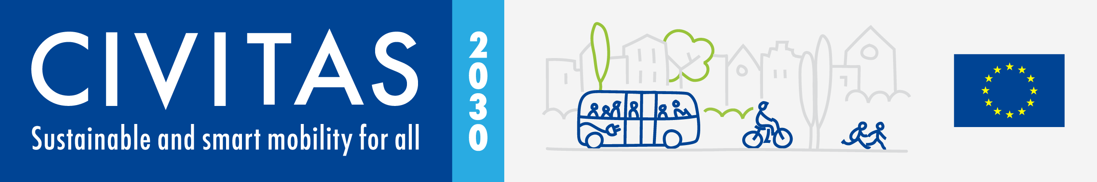
The FastTrack project has received funding from the European Union’s Horizon 2020 research and innovation programme under grant agreement no. 101006853.
Call for Participation
FastTrack CBW5 & Final Event in Budapest 16-17 May 2023

Project Acronym: |  | FastTrack
Full Title: Fostering the Acceleration of Sustainable Transport to Regions and Authorities through Capacity and Knowledge
Grant Agreement No.: | 101006853

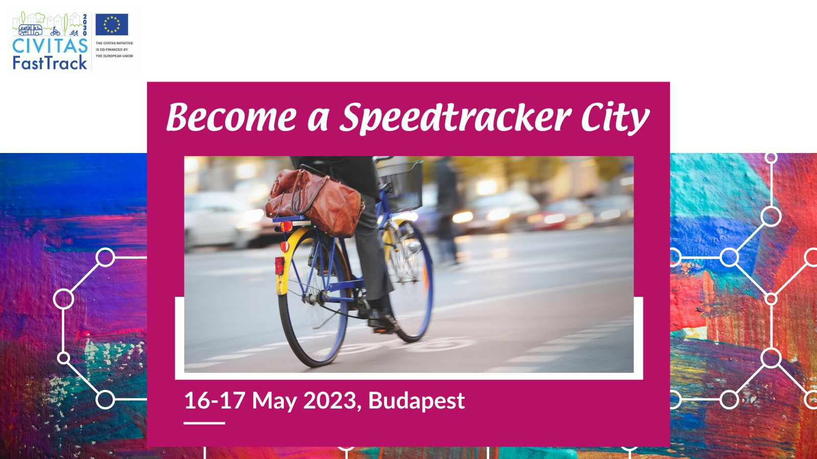
CIVITAS FastTrack Capacity Building Week 5 and Final event in a nutshell
CIVITAS FastTrack project is an initiative designed to support cities in gaining better access to innovative solutions and to address transport challenges by applying exchange mechanisms for transfer and take-up. Between 2021 and 2023, FastTrack organised four Capacity Building Weeks with workshops and study visits, for city representatives of 24 city authorities willing to learn from each other and to exchange extensively. All 24 participants developed further expertise on mobility innovations as well as a deployment plan on one mobility innovation they want to implement locally.
For more information on the project, visit our website: https://fasttrackmobility.eu/
This form is for cities interested and willing to take part as a Speedtracker city in the CBW5 in Budapest on 16th and 17th May 2023.
If you are selected as a Speedtracker city, you will:
- Receive advice on how to respond to one of your current city mobility challenges form our FastTrack community.
- Learn and be inspired about the outcomes of the FastTrack project on a variety of topics.
- Might be selected to receive financial support up to €750 to cover travel and accommodation for participating in the Capacity Building Week, after providing us with invoices.
Apply!
Do you want take part in the FastTrack CBW5 and final event as Speedtracker city?
Please fill in the application form by 20 March and send it back to annecharlotte.trapp@eurocities.eu

Contact person:
If you have any questions, please contact Anne-Charlotte Trapp: annecharlotte.trapp@eurocities.eu
ADDITIONAL INFORMATION TO READ BEFORE APPLYING
- What is the Capacity Building Week and Final event about?
The fifth Capacity Building Week and Final Event of the FastTrack project will be hosted by FastTrack Ambassador Budapest (Hungary) from 16 to 17 May 2023. Through a set of panel debates, co-creation workshops, the FastTrackers and the wider European network of mobility practitioners will have the opportunity to further exchange and learn about the outcomes of the project. FastTrackers will provide concrete lessons learnt and examples on how to FastTrack the uptake of mobility innovations. The participants will also have the chance to explore how the City of Budapest is connecting its Public Transport System in a smart way with other (micro) mobility options through a set of site visits organised on 17th May.
- What is a co-creation workshop?
For the co-creation workshops, the focus is on action learning. It fosters and broadens existing competence and knowledge by applying them to concrete cases. Participants work together in a workshop to co-design possible solutions to real cases of complex (mobility) challenges in cities. A specific city challenge is presented, discussed, and explored through situation-based group work. The workshop results in a set of ideas for actionable solutions that the representatives from the city concerned by the given challenge could take back home and consider acting upon. The logic is to generate ideas based on field experience and knowledge gained through previous workshops, to provide a fresh perspective to help a city that is looking out for innovative ways to tackle a pressing challenge it faces.
- Why joining the FastTrack CBW5 in Budapest?
If you are a Speedtracker city, you will:
- Have hands-on experience in another city through the site visits.
- Have the opportunity to exchange with leading peers and networks.
- Get personalised advice to one of your current mobility challenges.
- Learn more about how to accelerate the uptake of mobility solutions.
- What will be the tasks of cities involved?
If you are a Speedtracker city, you will:
- Identify a local challenge faced by your city.
- Prepare a short presentation of your challenge, guidelines and templates will be provide by the FastTrack project.
- Take actively part in the co-creation workshop

- What are the selection criteria?
If you submit your application on time, please note that:
- In total 4 cities will be selected & each of the 4 FastTrack cluster topics (see page 4) shall be covered.
- The more precisely the challenge is described in the form, the higher are your chances to be selected.

CIVITAS FastTrack Call for Speedtracker cities - Form

- Fundamental information
Name of the city & Country
Structure & size | ☐ City  ☐ Metropolitan area  ☐ Functional Urban Area  Population:
Are you member of the CIVITAS Community? | ☐ CIVITAS demonstration city  ☐ CIVITAS Forum network city  ☐ CIVINET member city  ☐ IA or RIA project partner city  ☐ None
Are you part of the Mission for Climate Neutral Cities?
Do you have recent experience of peer-to-peer exchange?  If yes please specify | ☐ Yes (Please specify below)  ☐ No

- Preparing the co-creation workshop
What are the main reason(s) why you want to take part in the FastTrack CBW5?
Which challenge from your city do you plan to present during the co-creation session?

Have you already identified a potential solution/innovation to tackle that challenge?
Which of the cluster topics covered by FastTrack interests you most? | ☐ Sustainable and clean urban logistics  ☐ Cycling in the urban and functional urban area  ☐ Integrated Multi-modal mobility solutions (Mobility hubs, MaaS, etc.)  ☐ Traffic and demand management

- Practicalities and joining instructions
Contact person(s) for the organisation of the intervention during CBW5: | Name:  Position:  Telephone:  Email:  Address: | Name:  Position:  Telephone:  Email:  Address:
Can you confirm and make sure that your colleagues have a sufficient level of English to present their experience? | ☐ Yes  ☐ No
How did you find out about the FastTrack CBW5?
Any questions to us?

Final declaration
I have the pleasure to inform you that the city of name of the city/region is interested to join the Capacity Building Week 5 as Speedtracker city.

Place
Click here to enter a date.
Name
Position
City/region

